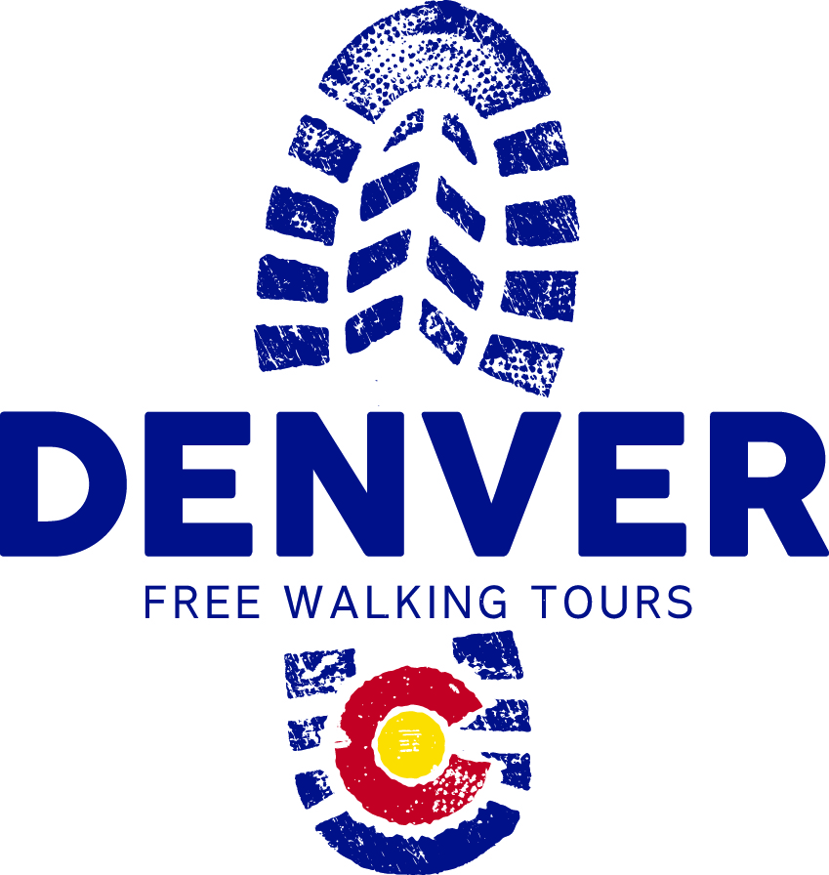

Marketing & Communications Intern Opportunity
2016
Denver Walking Tours
www.walkingtoursdenver.com
This internship opportunity is unpaid.
Interns may be (but do not need to be) in school and will receive course credit for the internship. If in school, interns with the following degree focus areas are especially encouraged to apply:
- Marketing
- Advertising
- Communications (SEO experience a plus)
- Business
- Public Relations
- Graphics
- Hospitality
- Customer Service/HR
- Journalism
Timing: Flexible start and end dates with projects and responsibilities tied to the intern’s interests, passions, and skill set.
Duties: If you think that you have the knowledge, the skills, and the passion to promote the service of Denver Walking Tours and make potential tour guests fall in love with this city as much as you are, we want to meet you!
The Marketing and Communications Intern’s responsibilities may include (dependent on intern skill set and interests):
- Manage and update website, including SEO
- Add store and booking functions and capacity to website
- Manage Social Media platforms, ensuring that engaging weekly content is posted
- Create press releases and other communication pieces (infographics, logos, etc.)
- Create and manage blog page on website
- Utilize technology to assist in creating audio walking tour mp3’s, phone apps, or other technology that will be marketed and sold online via the website
- Develop a list of strategic partners and/or potential clients that will lead to brand expansion and revenue increases
We are looking for interns who meet most of the following criteria:
- Knowledgeable about the city's culture and history
- Previous leadership experience
- Madly in love with Denver
Required Knowledge, Skills and Abilities:
- Must be able to read, write, and speak fluent English
- Ability to complete work by established deadlines
- Able to be available for occasional night and weekend conference calls and meetings, as needed
- Superb task management skills
- Dedication to outstanding customer service
- Knowledge of Denver history, architecture, and key downtown Denver tourist destinations is preferred
- Task oriented and highly motivated
- Reliable and timely
- High integrity and confidence
- Ability to work both independently and as a team member
- Exceptional personality

Qualifications:
- High School graduate or equivalent is required
- Access to internet and computer
- Knowledge of Microsoft Word, Facebook, and Google Drive for document sharing/collaboration
- Interest and/or knowledge of Denver history is preferred
- Prior marketing and communications experience is preferred

If you are an interested candidate, please send a cover letter, resume, and answers to the application questions below to Jill Collins: info@denverfreewalkingtours.com

Marketing and Communications Internship Application Questions
Please submit an application that answers all of the following questions:

- First & Last Name:
- Email:
- How long have you lived in Denver?
- Do you speak any languages, other than English, fluently?
- Tell us about any work experience that you have that pertains to this job:
- Describe where you would go and what you would do to show a visiting friend the best 24 hours ever in Denver. Your friend also shares that he/she doesn’t want to do only “touristy” things in the 24 hours they are visiting.
- Tell us about a significant leadership experience.
- What traits and/or strengths do you like most about yourself?
- What do you think is the most important quality or attribute of an amazing marketing and communications intern and why?
- Why should we hire you for this position?
- What is your year-round weekly availability (what days work, what days do not)?
- How many hours each week would you like to work as an intern?
- Last words – please add anything else you want to tell us!

